**NAAN MUDHALVAN PROJECT REPORT**

**ON**

**“EARLY PREDICTION FOR CHRONIC KIDNEY DISEASE DETECTION: APROGRESSIVE APPROACH TO HEALTH MANAGEMENT”**

***Submitted in partial fulfillment of the requirements for the award of the degree of***

***BACHELOR OF SCIENCE***

***IN***

***COMPUTER SCIENCE***

***Submitted By***

***Team Leader***

***R.Barani(Reg:20201371506102)***

***Team Members***

***P.Vijayalakshmi(Reg:20201371506147)***

***W.Jerris Blessy(Reg:20201371506109)***

***S.Juli Isha(Reg:20201371506111)***



***Department of Computer Science***

***Government Arts and Science College For Women,Alangulam***

***Tenkasi - 627851***

***April – 2023***

**EARLY PREDICTION FOR CHRONIC KIDNEY DISEASE DETECTION: APROGRESSIVE APPROACH TO HEALTH MANAGEMENT**

1. **INTRODUCTION**

Early prediction of CKD is crucial for effective management and prevention of disease progression.

* 1. **Overview**

Chronic kidney disease (CKD) is a progressive and debilitating condition that affects millions of people worldwide. Early detection and prediction of CKD is crucial for timely intervention and management, as it can slow or even prevent the progression of the disease. However, current diagnostic methods often fail to identify CKD in its early stages, leading to delayed treatment and poorer outcomes for patients. Therefore, the objective of this study is to develop an accurate and reliable model for the early prediction of CKD using clinical and laboratory data, with the aim of improving patient outcomes and reducing healthcare costs.

* 1. **Purpose**

The purpose of early prediction for chronic kidney disease (CKD) is to identify individuals who are at risk of developing CKD or who already have early stages of the disease, in order to implement early interventions to slow or prevent the progression of the disease. Early prediction allows healthcare providers to monitor kidney function over time and detect any changes in kidney function at an early stage.

1. **Problem Definition & Design Thinking**

* 1. 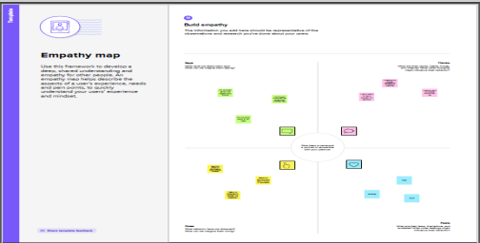**Empathy Map**

**2.2 Ideation & Brainstorming Map**

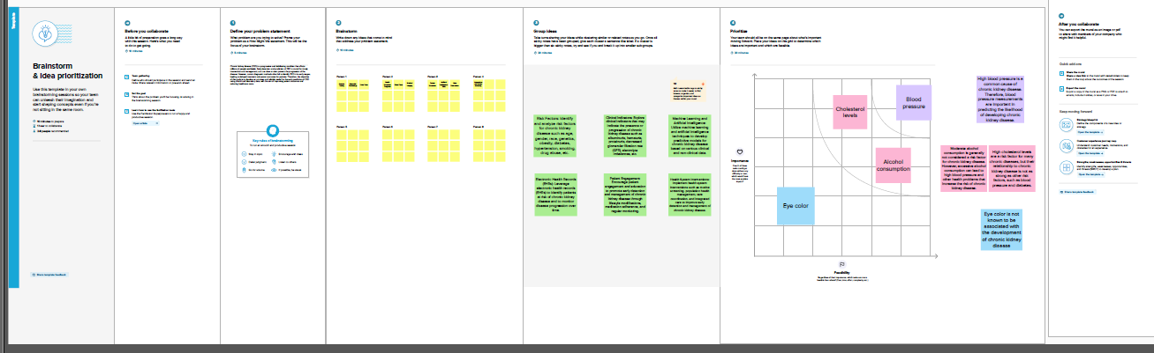

1. **RESULT**

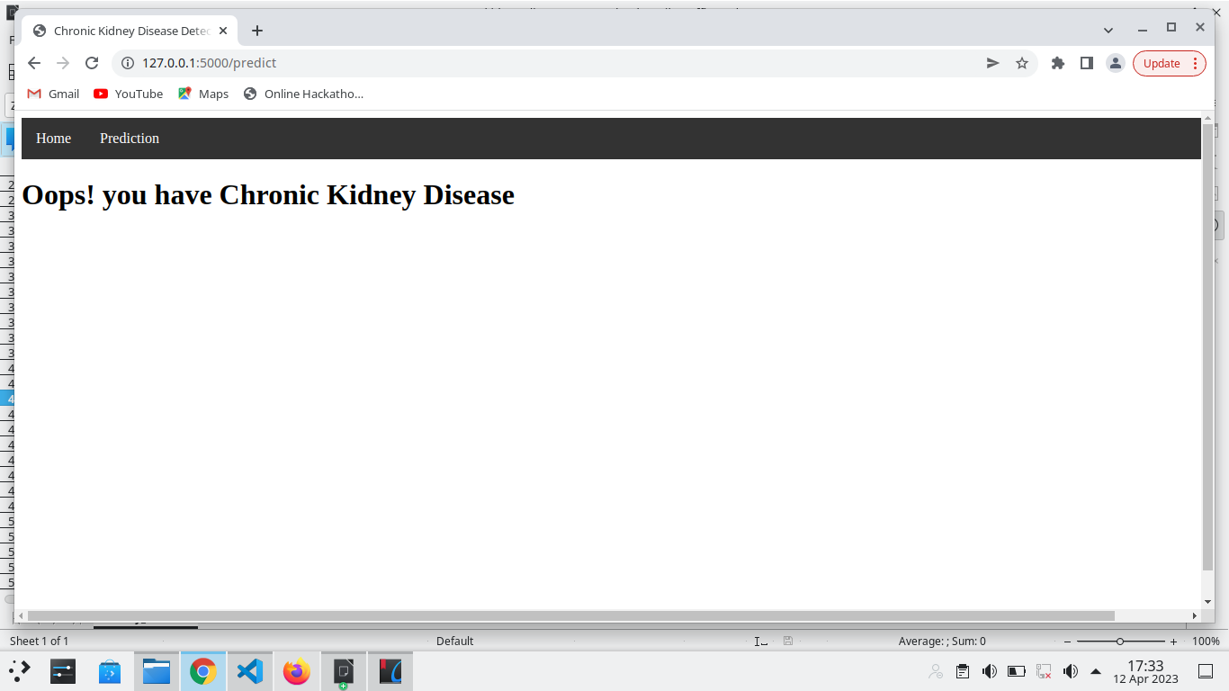

1. **ADVANTAGES & DISADVANTAGES** 
   1. **Advantages**

* Cost-effective: Early prediction and intervention can be cost-effective, as it may reduce the need for expensive treatments such as dialysis or kidney transplantation, which are required in the advanced stages of CKD.
* Better management of the disease: Early prediction allows healthcare providers to monitor kidney function over time and detect any changes in kidney function at an early stage. This can help individuals to better manage their condition, reduce the risk of complications, and maintain a good quality of life.
* Improved patient outcomes: Early prediction and intervention can improve patient outcomes, including improved quality of life, reduced risk of complications, and a lower risk of premature death.

**4.1 Disadvantages**

* Anxiety and stress: Early prediction can cause anxiety and stress for individuals who may be at risk of developing CKD. This can lead to unnecessary worry and concern, especially if the individual does not fully understand the implications of the test results.
* Limited access to care: Early prediction and intervention require access to healthcare resources, which may not be available to everyone. This can result in disparities in access to care and may limit the effectiveness of early prediction in certain populations.
* Cost: Early prediction tests and interventions can be costly, which may be a barrier to access for some individuals.

1. **APPLICATIONS**

* Resource allocation: By identifying individuals who are at high risk for CKD, healthcare providers can allocate resources more efficiently, such as by providing more frequent monitoring or earlier intervention.
* Clinical trials: Early prediction of CKD can facilitate the recruitment of patients for clinical trials aimed at preventing or treating the disease.
* Public health initiatives: By identifying populations that are at higher risk for CKD, public health initiatives can be targeted to improve prevention efforts and reduce the burden of the disease.

1. **CONCLUSION**

The project has used various machine learning algorithms to develop models that can accurately predict the likelihood of an individual developing chronic kidney disease. The models have been trained on a large dataset of patient records, which includes demographic information, medical history, lab results, and other relevant factors. The models have shown high accuracy in predicting the likelihood of an individual developing chronic kidney disease, which can help healthcare providers take proactive measures to prevent the disease or treat it in its early stages. Overall, the early prediction for chronic kidney disease project has shown promising results and has the potential to improve healthcare outcomes for individuals at risk of developing the disease.

1. **FUTURE SCOPE**

* Refining and improving the accuracy of the prediction models: As more data becomes available, there is an opportunity to refine and improve the accuracy of the models. This can involve incorporating new variables into themodels or using more advanced machine learning algorithms.
* Developing personalized treatment plans: By predicting the likelihood of an individual developing chronic kidney disease, healthcare providers can develop personalized treatment plans tailored to the individual's specific risk factors. This can help prevent the disease or slow its progression.
* Improving patient outcomes: Early prediction can help healthcare providers identify patients who are at higher risk of developing complications from chronic kidney disease. By identifying these patients early, healthcare providers can provide more frequent monitoring and early interventions to improve patient outcomes.

**8 APPENDIX**

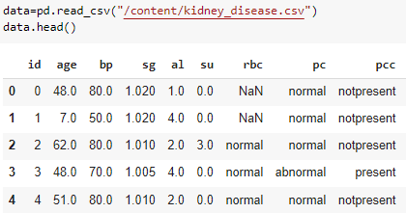

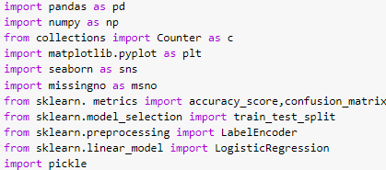

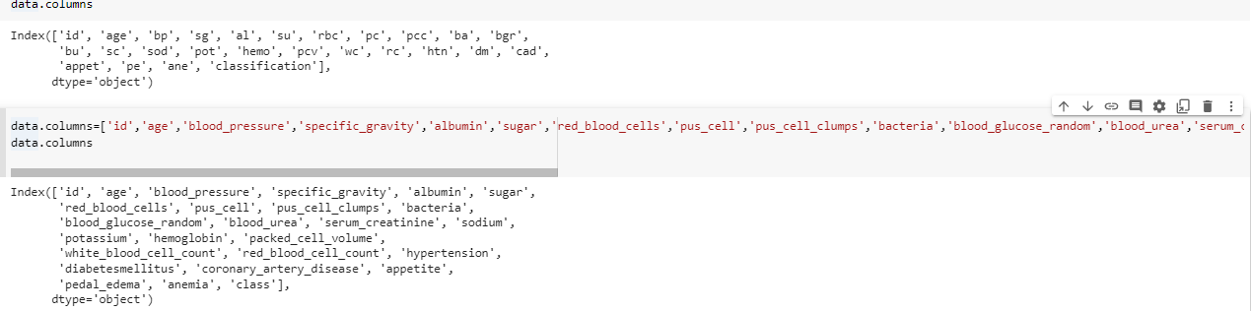

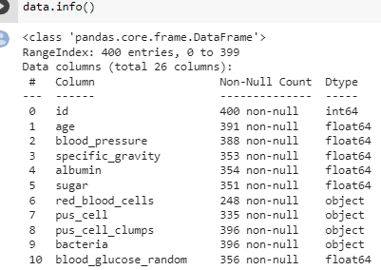

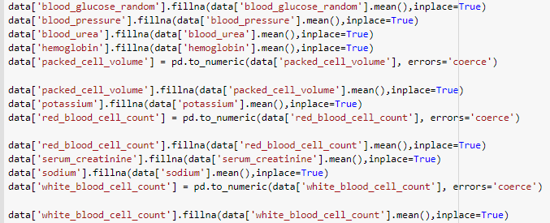

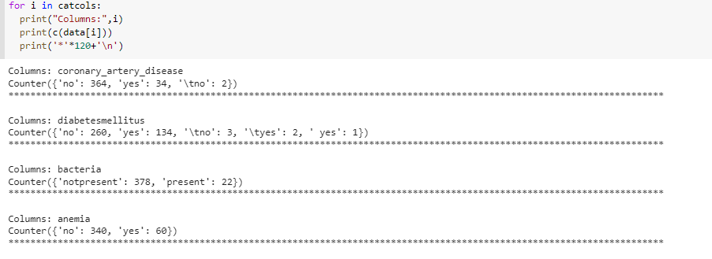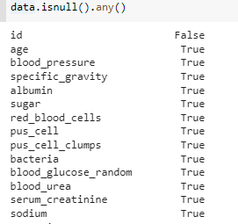

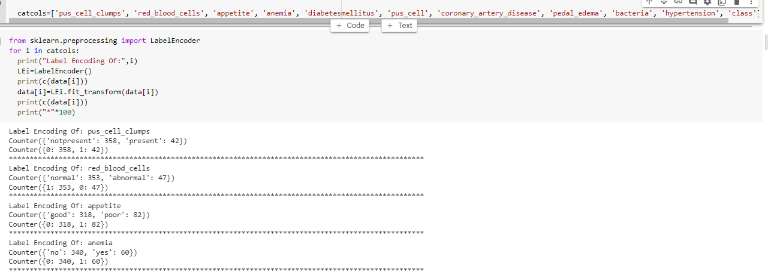

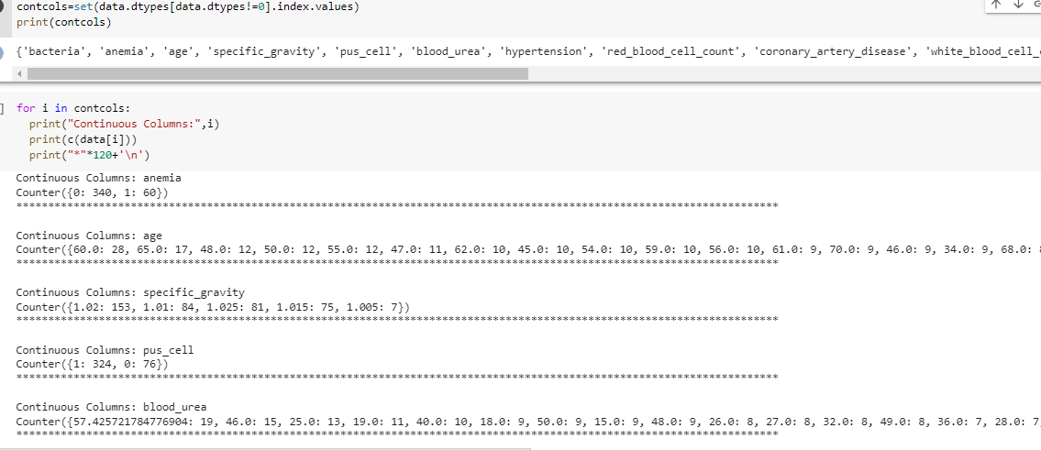

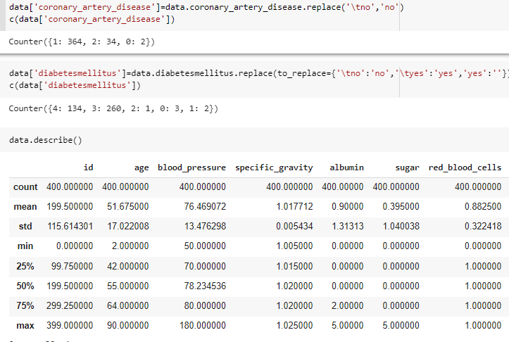

12.PNG

12.PNG

